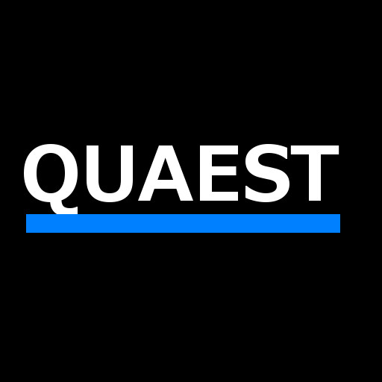 **Executive Summary**

**Quaest**

**HackATL 2015**

**Shirley Sun, Oleg Filatov, Pranav Shenoy**

**Mission**: Quaest is a micro-lending application that will enable users to lend and borrow small amounts in the short term at lower interest rates predetermined by the investor. It aims to become the platform for a community of small investors and borrowers.

**Business Description**: Quaest will make it easier to lend and borrow money. Interest rates charged by lenders are capped at 8%, significantly lower than that of most credit cards. Quaest will take 1% additional interest from the borrower at the time of the loan’s fulfillment.

Quaest will act as a third party entity for all transactions; if implemented, users would be required to e-sign an agreement absolving Quaest of any liability in the case of failure to repay.

**Product Description**: Users can connect their debit card and/or checking account routing number. They are then able to send and receive money directly. Quaest will keep a record of all transactions, and thus will be able to mediate any payment disputes. Users can make a profile, on which borrowers are able to give a short explanation of why they require a loan. Urgent borrowers can propose higher interest rates that they are willing to pay. The more loans successfully repaid, the more trusted a borrower becomes, which is reflected on their public profile. Lenders determine their interest rates and length of the loan. Generally, loans are short term with a timeframe of less than one year.

**Technology**: Quaest is currently available as an Android application. Android involves Java programming to create an application that is hooked to a backend coded in Firebase. For the purposes of our presentation, we have hard coded functionality. The backend server-side logic layer is hosted on Azure. Our application enables us to capitalize on this untapped market by applying mobile, social, and local technology.

**Implementation Strategy**: Quaest target demographics are students and young professionals with bills and living costs that need to be paid upfront who are waiting for their next paychecks. Quaest will advertise primarily through digital mediums such as social media and online advertisements. It also intends to have a strong presence on college campuses with university representatives, compensated on a commission basis, who will facilitate giveaways and tell their peers about Quaest. The biggest foreseeable challenge will be to find enough people willing to lend and to minimize their liability; however, the opportunity for a small lender to make money on Quaest is undeniable.

**Financial Overview**: The capital required for Quaest would cover operational costs, legal fees, security & fraud prevention, and marketing. Revenue is generated from the 1% interest rate that it receives from all loans. Quaest has the potential to be fully operational almost immediately after capital is raised.